Kevin Sanchez

CIS 233DA

Before you come to class

1. Screenshot of files 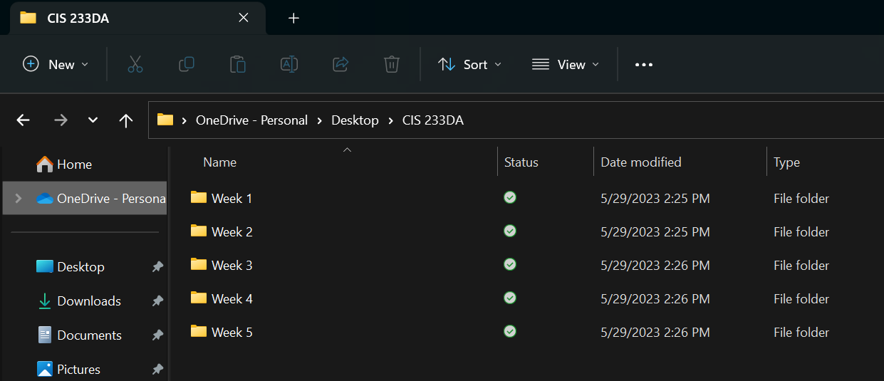
2. Screenshot of VS Code screen 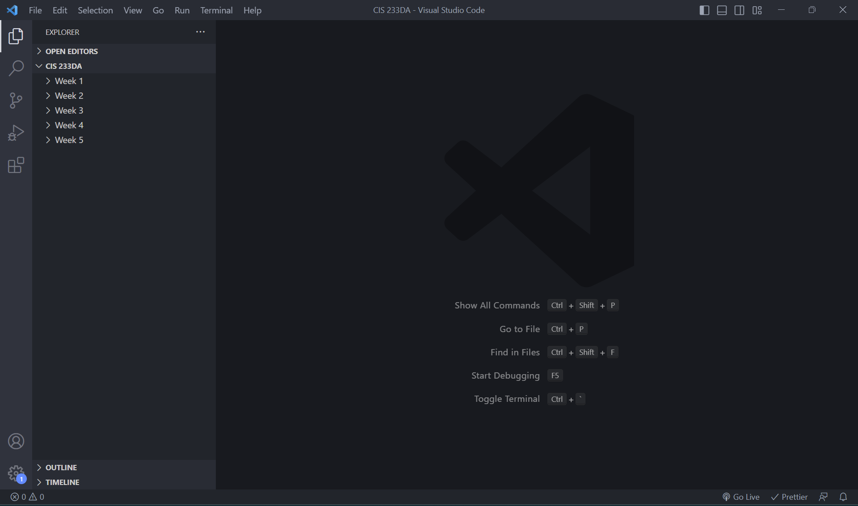
3. URL of GitHub repository

https://github.com/Kevin-Sanchez03/CIS233DA